**Primary areas**

**of theoretical linguistics**

**Contents**

**Section 1.** Linguistics as a science. Branches of linguistics ………...3

**Section 2.** The three main areas of linguistics………………………6

**Section 3.** Historical (comparative) linguistics….…………………10

**Section 4.** Structural linguistics…………..…………………………16

**Section 5.** A language as a system of signs.………………………...18

**Section 6.** Modern linguistics. Pragmatics as a branch of modern linguistics…………………………………………………………………..21

**Section 7.** Generative (transformational) linguistics…………………25

**sections 1. Linguistics as a science. branches of linguistics**

**Questions to discuss.**

1. Definition and object of linguistics.

2. Linguistics as a humanitarian science.

3. Branches of linguistics: theoretical and applied linguistics, general and special linguistics, synchronic and diachronic linguistics, external and internal linguistics.

**QUESTION 1. Definition and object of linguistics.**

**Linguistics** is the study of natural human language, its structure, functions, historical development, classification, etc. Thus, the **object** of linguistics is natural human language.

There are many definitions of the concept of "language". In the most general sense, the notion of "**language**" can be defined as a system of signs (symbols) that are used for communication and understanding the world. Language is a social phenomenon, not a biological one (yet it is genetically predetermined), but it is not purposefully created.

The **subject** of linguistics is the structure and functions of language, patterns of historical development, classification of languages, etc.

**QUESTION 2. Linguistics as a humanitarian discipline**

A humanitarian science is the study of a person and people, their social activity.

Since the language does not exist by itself, but within a person, as it is associated with the thinking and consciousness of a person and is the most important means of human communication, linguistics is known as one of the central humanitarian sciences that study Man and human society.

So, sometimes linguists say that the object of linguistics is not a language, but the object of linguistics is “homo loquens” (Latin). The term *homo loquens* (from the Lat. *homo* “person, people” and *loquens* “talking”), means a speaking (writing) person, listening (reading) person, and in a broad sense – a person involved in speech communication.

**QUESTION 3 Branches of linguistics**

***Theoretical linguistics*** focuses on acquiring new knowledge about the language. It tries to understand how languages function, how they appear, evolve and disappear.

***Applied linguistics*** uses the scientific knowledge about language and speech obtained by theoretical linguistics to solve practical problems (often outside linguistics itself): creating and improving writing, teaching how to write, teaching speech culture, teaching non-native language, creating automatic translation systems, automatic information search, speech recognition and synthesis. Applied linguistics also covers such types of non-scientific activities as teaching children their native language, literary editing, artistic word-making.

Theoretical linguistics can be **general** and **special**, **synchronic** and **diachronic**, **external** and **internal**.

**General linguistics** studies the general features of human language, examines the essence and nature of language, its origin and the general laws of its development and functioning. **Special** linguistics studies a single language (Russian, English, Chinese, Spanish, etc.) or a group of related languages (Slavic, Germanic, Turkish).

**Synchronic linguistics** describes the facts of the language at some point in its historical development (for example, modern Russian), **diachronic linguistics** traces the development of the language over a certain period of time.

**Internal linguistics** studies the structural and system relations of language units without reference to external linguistic factors, i.e., language as a code, a sign system. **External** linguistics studies the totality of ethnic, social, historical, and geographical factors that are connected with the development of the language.

**Conclusion**: language is a multidimensional phenomenon, so linguistics is also a diverse (versatile) science.

**Section 2. The three main areas**

**of linguistics**

***Questions to discuss***

1. Comparative Linguistics (Historical Linguistics).

2. Structural Linguistics (Structuralism).

3. Anthropocentric Linguistics.

**Question 1. Comparative Linguistics (Historical Linguistics).**

We already know that linguistics is the study of the natural human language (today we can also say that linguistics is the study of *homo loquent* “a speaking person”).

As a science, linguistics formed in the 19th century when it developed its own research method (***the comparative method*** which helped establish genetic/genealogical relationship between languages), so the first stage of linguistics development is called comparative linguistics (historical linguistics).

But before we start speaking about it, we should know that all in all linguistics is divided into **3 main periods** (stages of development). They are as follows:

1) comparative linguistics (historical linguistics): 19th century – today,

2) structural linguistics (structuralism): 1900s – today,

3) anthropological linguistics (modern linguistics): 1950s – today.

Of course, primarily we shall focus on comparative linguistics as it is the first period of linguistics evolution.

***Question 1. Comparative linguistics (historical linguistics)***

**Comparative linguistics (historical linguistics)** is about **comparing languages** to establish their historical relatedness. Or we can say that comparative linguistics (historical linguistics) is a field of linguistics that primarily deals with **the kinship of languages**, establishing to what degree languages are related to each other.

Objectives of comparative linguistics:

* building a genealogical classification of languages,
* reconstructing proto-languages,
* studying diachronic processes in the history of languages,
* uniting languages into groups and families,
* studying etymology of words.

Historical linguistics groups all the languages of the world into ***language families***. For example, now we know that the English language belongs to the Indo-European Family, while the Chinese language belongs to the Sino-Tibetan family.

**Language families of the world**

1. Niger-Congo (1,542 languages) (21.7%)

2. Austronesian (1,257 languages) (17.7%)

3. Trans-New Guinea (482 languages) (6.8%)

**4. Sino-Tibetan (455 languages) (6.4%)**

**5. Indo-European (448 languages) (6.3%)**

6. Australian (381 languages) (5.4%)

7. Afro-Asiatic (377 languages) (5.3%)

8. Nilo-Saharan (206 languages) (2.9%)

9. Oto-Manguean (178 languages) (2.5%)

10. Austroasiatic (167 languages) (2.3%)

11. Tai-Kadai (91 languages) (1.3%)

12. Dravidian (86 languages) (1.2%)

13. Tupian (76 languages) (1.1%)

So, a language family is a group of related languages that come from a common ancestral language (parent language), called the proto-language of that family. Thus, languages within a family are genetically connected.

**Question 2. structural linguistics (structuralism).**

While historical linguistics is diachronic linguistics (traces the development of the language), ***structural linguistics is synchronic linguistics*** (describes the facts of the language at some point in its historical development).

Structural linguistics (structuralism) focuses on two main notions:

1) language system (a set of linguistic elements that are in relations and connections with each other, which forms a certain integrity, unity)

2) language structure (a set of linguistic components and a set of connections between them).

Structural linguistics divides natural human language into simpler components **(sounds, morphemes, words, sentences)**, and insists on the idea that properties of an individual component can be understood only in connection with other components. Structuralism is the leading trend in linguistics of the first half of the 20th century. (The term "structuralism" was first used in 1939 in an article by the Dutch linguist H. Poss).

Basic ideas of structuralism:

***Basic ideas of structuralism:***

1) language is a structural formation in which all its units are connected by various relations;

2) studies language as a code, a sign system, as a system of symbols (the word is the main symbol);

3) we should differentiate between such notions as “language” and “speech”;

4) all the elements within a language system are connected both syntagmatically and paradigmatically. ***Syntagmatic relations*** between language elements are linear relations/speech relations, i.e. relations between language units in speech. ***Paradigmatic relations*** are relations of oppositions between language units.

The focus of structuralism was on the word.

So, structural linguistics states the idea that any language is an innate phenomena that doesn’t depend on extra-linguistic factors (historical,cultural, psychological).

**Question 3. Anthropocentric linguistics**

Modern linguistics is anthropocentric linguistics (it starts in the 1950s). It states that language does not exist by itself, language exists only inside the individual mind, only in our souls, only in the psyche of the individuals or individuals who make up a particular linguistic society. The object of the study is the person within the language and the language within the person, a speaking person (*homo eloquent*). So, modern linguistics focuses on a person, and language is considered the main characteristic of a person, its most important component. Language “lives” inside a person and has no sense without a person.

Anthropocentric linguistics includes ***the following branches***:

- cognitive linguistics (it studies human language as a means of understanding and generalizing human experience, as a means of storing information);

- cultural linguistics (it studies the language as a means of transfer (compiler) of the material and spiritual culture of the nation; it also studies relations between languages and human culture),

- communicative linguistics (linguistic pragmatics) – studies the human language as a means of communication,

- ethnological linguistics (it studies relations between the language and its nation),

- psychological linguistics (it studies language as a means of speech representation of thoughts),

- social linguistics (it studies the relations between culture and language).

**Conclusion.**

1. three main periods (areas) of linguistics are: **comparative linguistics, structural linguistics, and anthropocentric linguistics;**

2) **structural linguistics** is internal (**internal linguistics** studies the structural and system relations of language units without reference to external linguistic factors),

3) **historical and anthropocentric linguistics** are both external (**external linguistics** studies the totality of ethnic, social, historical, and geographical factors that influence the use and development of the language).

4) although **modern linguistics is known as anthropocentric** linguistics, nevertheless all the three areas are still popular today, all of them are important because they help have a look at the language from different perspectives.

**Section 3**

**comparative (historical) linguiStics**

**(the 19th century – today).**

***Questions to discuss.***

1. Objectives and principles of comparative (historical) linguistics. Genealogical classification of languages.

2. Branches of historical linguistics.

***Question 1****.* ***Objectives and principles of comparative (historical) linguistics. Genealogical classification of languages.***

Compare the following words in different languages:

English: *three* (3)

Russian: *три* (3)

Spanish: *tres* (3)

French: *trois* (3)

German: *Drei* (3)

Sanskrit: *tre* (3)

Latin: *trēs* (3)

As we can clearly see, these words look very much alike and mean the same thing – ‘3’. If languages have quite a number of similar words, it can mean that they come from a common ancestor language (parent language). For example, Russian, English, Spanish, French, Latin, Sanskrit, etc. go back to the same source – ***the Proto-Indo-European language (around 5000 BC)*** that had split into a number of other languages before it died (see the Picture below).

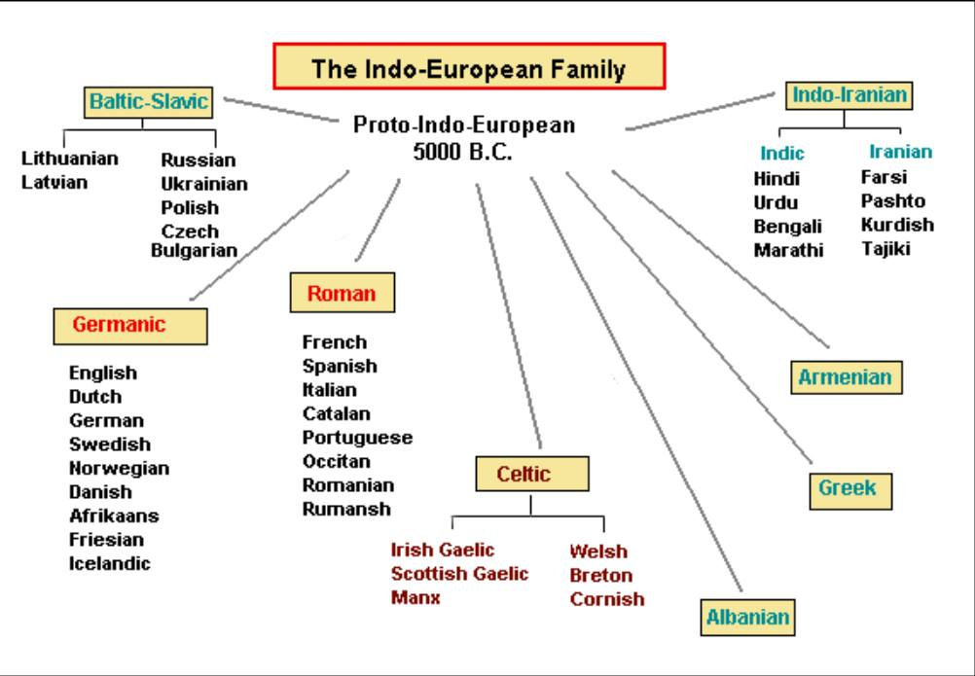

The area of linguistics that compares languages to establish their genetic relatedness is known as ***comparative linguistics (historical linguistics)*** that started in the 19th century.

***The object*** of comparative (historical) linguistics is related languages. ***The subject*** is the kinship of languages (language similarities). ***The objective*** is to establish relations between related languages and describe their evolution/development, to build a genealogical classification of languages.

Today, the genealogical classification of languages can look like this:

***Language families***

1. Niger-Congo (1,542 languages) (21.7%)

2. Austronesian (1,257 languages) (17.7%)

3. Trans-New Guinea (482 languages) (6.8%)

**4. Sino-Tibetan (455 languages) (6.4%)**

**5. Indo-European (448 languages) (6.3%)**

6. Australian (381 languages) (5.4%)

7. Afro-Asiatic (377 languages) (5.3%)

8. Nilo-Saharan (206 languages) (2.9%)

9. Oto-Manguean (178 languages) (2.5%)

10. Austroasiatic (167 languages) (2.3%)

11. Tai-Kadai (91 languages) (1.3%)

12. Dravidian (86 languages) (1.2%)

13. Tupian (76 languages) (1.1%)

Each of these language families can be divided into ***language branches***. For example, the Indo-European languages split into Indo-Iranian, Roman, Germanic, Slavic and other language branches (see the Picture on page 1). As for language branches, they can split into ***language groups***. For example, the Germanic branch is divided into the following language groups – the West Germanic group, the North Germanic group, the East Germanic group (see the Picture below):

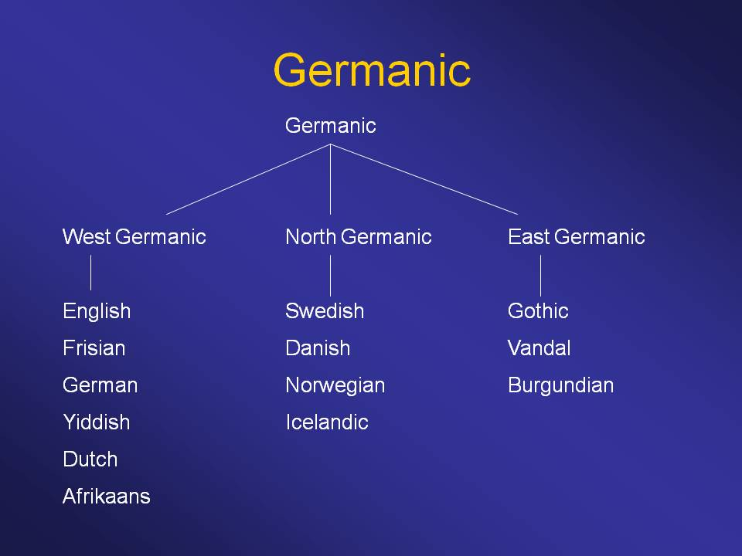

**Just to sum up:**

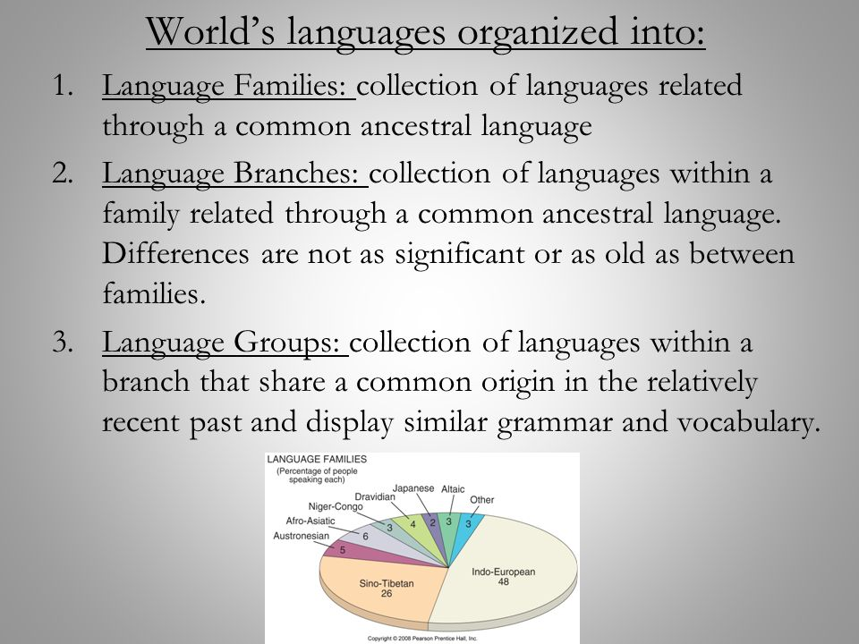

Languages that belong to the same group are **very close relatives** (like a brother and a sister).

Languages that belong to the same group but different groups are **not so** **close relatives** (like cousins).

Languages that belong to the same family but different branches are **very distant relatives** (but still relatives).

***Proofs that languages are genetically related (phonetic, lexical and grammatical similarities)***

Historical linguists believe that it is a bad sign if the words in different languages coincide completely or almost completely – it means that languages are not genetically related, and one language simply adopted the word from another language.

For example, we can find the word “discourse” in both English and Russian, but it does not prove anything because we know that the word “discourse” is of Latin origin. First, the French language adopted this word from Latin. Then the English language as well as some other languages (like Russian) borrowed this word from French. So, the word “discourse” is just a borrowing, and we shouldn’t take into account borrowings when establishing the degree of relatedness between languages.

A true sign of the genealogical relatedness of the languages is a partial coincidence of the words because the sound form of the word changes in each language in its own way over time.

For example, it may seem impossible to compare such words as the Russian word ***жена*** ‘*wife’* and Norwegian ***kona*** ‘*wife’*, but if we know that in the Scandinavian Germanic languages the sound [g] transformed into [k] and if we know that in some words of the Slavic languages [g] transforms into [ж], then we can see that the Norwegian ***kona*** and Russian ***жена*** come from the same word that existed in their parent language.

So, the comparative method is based on the following principles:

1) when comparing languages we have to take into account ***sound similarities***. The complete sound coincidence of the forms of words in different languages cannot show or prove anything. On the contrary, partial coincidence of sounds may be the most reliable proof for the kinship of languages;

2) ***words*** that appeared just a few centuries ago are not suitable for comparing languages. What words are suitable for comparing languages? They are names of kinship (*mother, brother, sister*, etc.), numerals (*one, two, three … ten*), some native pronouns, words denoting body parts, names of some animals, plants, tools, i.e. words that could be used in the parent language which belonged to some primitive society. If these ancient words look alike in different languages, it is a true sign that these languages are genealogically related.

3) it is also necessary to take into account ***grammatical similarities***. For example, if the category of time is expressed in some languages similarly, it is a true sign that the languages are genealogically related.

***The founders of historical linguistics:***

***1) Franz Bopp*** (1791–1867) – analyzed an extensive language material and proved that all the Indo-European languages have a common ancestor (he compared Sanskrit with Greek, Latin, Persian and Germanic languages and found that all the European languages are related to Sanskrit, because they have common grammatical features;

***2) Rasmus Rask*** (1787–1832) – published a work where he compared all the Indo-European languages known by that time;

***3) Jacob Grimm*** (1785–1863) – created a comparative-historical grammar of all Germanic literary languages and dialects, i.e. described common features and differences of related Germanic languages (compared the sounds of Germanic languages with Scandinavian consonants and other Indo-European languages, and also revealed the relationship).

***Question 2. Branches of historical linguistics***

***1. Naturalistic (biological) branch of historical linguistics– 1800–1850 (A. Schleicher, Moritz Rapp, Max Muller, etc.)***

A. Schleicher believed that languages behave like living organisms, i.e. they are born, grow, mature and fight with each other for existence, grow old and die. So, A. Schleicher applied *Ch. Darwin's theory of the struggle for existence and natural selection* to linguistics. Language was believed to be a biological phenomenon. So, linguistics was a natural science for him. He borrowed the terms of natural sciences into linguistics: *language family, language organism, family tree*, and many other terms of genealogical classification: *branch, proto-language, close and distant kinship of languages*.

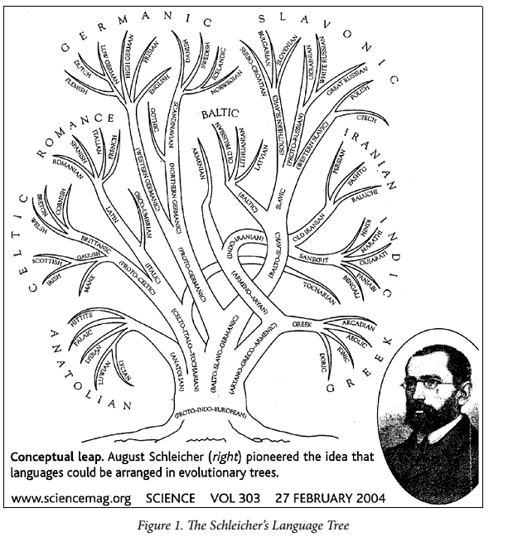

**2. Psychological branch of historical linguistics (Heyman Steinthal, Moritz Latsarus, Wilhelm Wundt, etc.): 1850–1900.**

Representatives of this branch believed that a language is a reflection of a nation’s psychology and spirit. A language is understood as a product of some national community, its psyche, self-identity, its vision of the world and its spirit.*A man was believed to be a member of a certain national community all the representatives of which see the world in the same way because their language makes them do it.*At that time linguistics was known as a psychological science, while a language was a social phenomenon.

***3. Neogrammarian school of linguistics (A. Leskin, B. Delbrueck, G. Paul, G. Osthof, K. Brugman) – 1870–1900.***

The focus of neogrammarians was on the speaking person. It was also a psychological branch of historical linguistics but they believed a language to be an individual phenomenon (not a social one). It means that neogrammarians believed that there are no national languages at all: there is no English language, there is no Chinese language, there is no Russian language, but there is Mr. White’ language, a little girl Mary’s language, the professor Bannister’s language, etc. So, neogrammarians believe that there are as many languages in the world as there are people on our planet.

**Conclusion.**

Historical linguistics is still popular today. Moreover, today we believe that a language is a national (social) phenomenon and represents the “spirit” of the nation.

**Section 4**

**Structural Linguistics**

**(the beginning of the 19th century–now)**

***Questions to discuss***

1. What is structural linguistics (structuralism)?

2. Schools of structuralism

***Question 1. What is structural linguistics (structuralism)?***

***Structuralism*** is an area of linguistics that states:

- a language is a system of structural elements (sounds, syllables, words, word-groups, sentences, etc.),

- a language is a system of symbols/signs (the basic symbol is a word).

The term "structuralism" was first used in 1939 in an article by the Dutch linguist H. Poss.

But the founder of linguistics was the Swiss linguist Ferdinand de Saussure (1857–1913).

F. de Saussure interpreted a language in the following way:

1) a language is a social phenomenon,

2) a language and speech are different things (a language is a code that is used for communication, while speech is a message in a language),

3) language is an abstract phenomenon, while speech is material,

4) a language is a national phenomenon while speech is an individual phenomenon.

Ferdinand de Saussure believed that linguists should study a language (not a speech!).

***Dichotomies proposed by F. Saussure:***

1) speech vs. language;

2) dichotomy vs. synchrony;

3) paradigmatic relations vs. syntagmatic relations.

***Question 2. Branches (schools) of structuralism.***

***1. The Prague school (1926–1952).***

**The founders and representatives:** Vilém Mathesius, Bohuslav Havránek, Vladimír Skalička, Bohumil Trnka, Roman Jakobson, Sergej Karcevskij, etc..

**Its motto** was *structure and function* (this is why the school is often known as the School of functional linguistics). For them: a language is a functional system of symbols that is used to reach some communicative goal.

While F. de Saussure believed *a language* to be a true research object of linguistics, representatives of the Prague school concentrated on *speech*.

***2. The Copenhagen School (The Danish School).***

It was founded by Louis Hjelmslev (1899–1965). He developed the theory of language known as glossematics. The word “glossematics” derives from the Greek word *glossa* (meaning here "language") and the *seme* (meaning “sign”).

The principal ideas of the Copenhagen school are:

- a language is an abstract phenomenon,

- a language consists of content (form) and expression (meaning),

- content and expression are interconnected by different relations,

- linguistics should focus on these relations as well as on the interdependencies (functions) between language units (words, syllables, sentences).

The main weak points of this school:

- they showed an extremely formal approach to a language (the role of extra-linguistic factors was underestimated);

- they didn’t take into account the features of particular languages.

***3. Descriptive linguistics (American structuralism).***

It was founded by Franz Boas (1858-1942), Edward Sepir (1884-1939) and Leonard Bloomfield (1887-1949).

The school didn’t explain why a language is arranged and used the way it is but rather focused on registering and *describing* language elements (that is why it is called descriptive linguistics).

Bloomfield's approach to linguistics was characterized by:

- its emphasis on formal procedures for the analysis of linguistic data

- its adherence to behaviorism (a psychological theory that states that behavior is simply a response to environmental stimuli). For Bloomfield, a language as a special form of human behavior. Language processes are like biological processes, communication is a chain of stimuli and reactions to them.

***Conclusion.***

Although the three schools of structuralism (the Prague School, the Copenhagen School and Descriptive Linguistics) share a common idea that language is a system of signs and structural formation, nevertheless, each school interprets a language in its own way.

**Lecture 5.**

**a Language as a system of signs**

**(semiological character of a language).**

***Questions to discuss:***

1. What is a sign?

2. What is a language sign?

3. Classification of signs.

**As we know from Section 4, structural linguistics believes that a language is a system of signs.**

**Question 1. What is a sign?**

We live in the world of signs and symbols. Signs are all around us and accompany us everywhere. For example, we know perfectly well that when the alarm clock rings, it's time to get up. Or when we nod a head, it means agreement and consent.

A few more examples of signs: road signs, banknotes, mathematical symbols, formulae (like E = MC2), musical noted, a ringing bell (in school), animal signs (like hissing or barking).

But why is the problem of signs should be interesting o linguists? Because all words in a language are also signs.

So, what is a sign?

***A sign*** is a substitute of a real object or phenomenon (@, $, %, &, ^, *, etc. are examples of signs). For example, a picture of a horse is a sign because it substitutes a real horse. Or the word “ice-cream” is used to denote real ice-cream.

The branch of linguistics that studies a language as a system of signs is a structural linguistics.

Any thing can function as a sign if it possesses the following properties.

***Sign properties (characteristics):***

***1) social character*** is an ability of a sign to function in a particular society (community): for example, the same gestures in different cultures have different meanings (e.g. a nod of the head in most countries denotes agreement, while in Bulgaria it means disagreement). One more example: every language uses different words to denote the same thing: the English language uses the word “cake” to denote a real cake, but the Russian language uses the word “торт” to denote the same thing;

***2) communicative character*** – an ability of a sign to be carry and transmit information deliberately (on purpose),

3***) conventional character*** – a sign is a result of some agreement in a society (the meaning of the sign is known to all the members of the society). For example, everybody knows that raising a hand in class expresses a student’s desire to answer or ask a question;

***4) bilateral character***, which means that any sign is of double nature – it has both the signifier (form/expression) and the signified (meaning/content). The signifier is the material/physical side of a sign (for example, audial or visual). The signified is the information that the sign carries;

***5) system character***, which means that a sign is an element of a whole system of signs (for example, “+” and “-” are two signs of a whole arithmetic system of signs);

***6) general character***, which means that a sign often denotes not a particular object but a whole class of objects. For example, the word “pizza” doesn’t denote a particular pizza but any pizza.

**Question 2. What is a language sign?**

*The main language sign is* ***a word*** because it substitutes a real phenomenon.

***Properties of language signs (words):***

***1) a linear character***, which means that a sign is extended in space and in time (it takes us some time to pronounce a word; as for a written word it takes some space on paper to write it down)

***2) an arbitrary character***, which means that we often don’t know why a cat is called a cat, or why scissors are called scissors;

**Question 3. classification of signs.**

All signs (including language signs) can be classified in the following way:

***1) on the basis of their origin***: *biological* signs (used by animals, plants, etc.) and *anthropocentric* signs – that can be both **natural** (e.g., a human language) and **man-made** (e.g., road signs);

***2) on the basis of their material representation:*** *visual* signs (pictures, photos, road signs), *audio* signs (a bell ringing, signalization, etc.), *kinesthetic* signs (Braille alphabet, etc.), *flavouring* signs (often used by plants/animals to frighten animals), *osmatic* signs (often used by plants/animals to frighten enemies);

***3) on the basis of whether they are used deliberately or accidentally:*** *real signs* (a student raises his hand to show that he/she is ready to answer) or *pseudo-signs* (coughing signifies that a person has caught a cold but this person doesn’t show it on purpose);

***4) Ch. Pierce’ classification of signs:***

- symbols (signs that do not resemble the object that they denote): numbers, most words in a language, musical notes, etc.;

- icons (signs that resemble the object that they denote); photos, pictures, graphics, schemes, most road signs, etc.;

- indices (indicators, pointing devices): direction arrows, gestures, facial expression, some words in a language (pronouns, interjections, words like “here” and “there”, “now”).

***Conclusion.***

The science that studies signs is known as ***semiotics***. So, linguistics is considered to be a branch of semiotics because it believes words to be signs (substitutes of real objects).

**Lecture 6**

**modern linguistic. Pragmatics as a branchof modern linguistics**

***Questions to discuss:***

*1. What is modern linguistics about?*

*2. Branches of modern linguistics.*

*3. Pragmatics as a branch of modern linguistics.*

***Question 1. What is modern linguistics about?***

We already know that ***3 primary areas of linguistics*** are:

1) comparative linguistics (historic linguistics),

2) structural linguistics (structuralism),

3) modern linguistics.

In this lecture, we’ll speak about anthropocentric linguistics.

Modern linguistics is ***anthropocentric linguistics*** (it starts in the 1950s). IIt means that its basic idea is that a language is part of a person and part of some national community. The true object of linguistics is not a language but a speaking person (*homo loquent*) or speech which is influenced by a number of external factors: psychological, cultural, situational, etc.

***Question 2. Branches of modern linguistics.***

Modern linguistics includes the following branches:

- ***cognitive linguistics*** (it studies human language as a means of understanding and generalizing human experience, as a means of storing information);

- ***cultural linguistics*** (studies the language as a means of transfer (compiler) of the material and spiritual culture of the nation; it also studies relations between languages and human culture),

- ***communicative linguistics*** (linguistic pragmatics) – studies the human language as a means of communication,

- ***ethnological linguistics*** (studies relations between the language and its nation),

- ***psychological linguistics*** (studies language as a means of speech representation of thoughts),

- ***social linguistics*** (studies peculiarities of the sublanguages).

***Question 3. Pragmatics as a branch of modern linguistics.***

One of the main branches of modern linguistics is ***pragmatics.***

***The basic idea*** of pragmatics: a language is a means of communication and an instrument to influence our mind and emotions.

The main ***objectives*** of pragmatics:

1) to define the principles of communication,

2) to classify speech acts.

***The first objective*** is to define the principles of communication.

The first linguists who defined the principles of communication were Herbert Paul Grice and Geoffrey Leech.

***P. Grice*** proposed ***the Cooperative principle***.

The cooperative communication is communication based on the following maxims:

**Maxim of Quantity (**Information)

* Make your contribution as informative as is required for the current purposes of the exchange.
* Do not make your contribution more informative than is required.

**Maxim of Quality (**Truth)

* Do not say what you believe to be false.
* Do not say that for which you lack adequate evidence.

**Maxim of Relation (**Relevance)

* Be relevant.

**Maxim of Manner:** Clarity ("be perspicuous")

* Avoid obscurity of expression.
* Avoid ambiguity.
* Be brief (avoid unnecessary prolixity).
* Be orderly.

One more classification of principles of communication was proposed by ***G. Leech*** who introduced ***the Principle of Politeness***.

He interpreted the term “polite communication” in a very specific way. For him ***a polite massage*** (speech act/utterance) is a message that requires no or minimum efforts (physical or intellectual efforts) of the interlocutor. For example, when we want our husband/wife to go to the bakery (which requires certain efforts on the part of my husband/wife), we can put it differently:

*Go and get some bread.*

*Go and get some bread, please.*

*Can you go and get some bread?*

*Could you go and get some bread?*

*Couldn’t you go and get some bread?* Etc.

While the first sentence is very direct and sounds like a request (which implies efforts on the part of the husband/wife), the final sentence looks like a harmless question, like something unreal (because it’s a conditional question) which seems to reduce the efforts on the part of the interlocutor. That is why the every next sentence sounds more polite than the previous one.

So, *the more the efforts that are required on the part of the interlocutor, the more indirect your message should be.* And vice versa: *the less the efforts that are required on the part of the interlocutor, the more direct the formulation of the message is.* For example, there is no need to say something like “Will you be so kind to let me fix your computer?” because your interlocutor does not need to apply any efforts. So, it’s enough to say: “Let me fix your computer”

G. Leech distinguishes the following ***maxims of the Principle of Politeness***:

* *the Tact Maxim* (to reduce efforts of the interlocutor and to increase his/her benefits),
* *Generosity Maxim* (to reduce your benefits and to increase your efforts),
* *Approbation (approval) Maxim*,
* *Modesty Maxim*,
* *Agreement Maxim*
* *Sympathy Maxim*

***The other objective*** of the communicative linguistics is classification of speech acts.

Let’s classify (define types of) speech acts on the basis of the following parameters/criteria:

1) their communicative goal (illocutionary force/function, intentions of the speaker),

2) the way the communicative goal is expressed.

1. ***The criterion “the illocutionary force/communicative goal”*** helps us differentiate between the following ***types of speech acts*** (John Searle and Daniel Vanderveken, 1986):

**- assertives/representatives** – statement (memo, confirmation, disagreement, etc.): *It's going to rain tomorrow. She came back late yesterday.*

- **directives** – speech acts expressing inducement, acts that make us do something, imperative speech acts (request, order, advice, recommendation, demand, etc.): *Please, don’t forget to buy some milk on your way home.* *Could you do it for me? The passengers are welcome to proceed to the boarding gate. I’m cold. You should eat more.*

***-* interrogatives/questions** – requests for information: *When are you leaving? I'd like to know when you'll be back.* (the last sentence contains no formal markers of a question. Nevertheless it should be interpreted as a question because it’s a request for information)

**- commisives/promissives** – promises, guarantees, etc*.). I will be on time. I'll fix it this weekend. I will definitely do it!*

- **menacives** – threat: *You’ll pay for it. I’ll give away all your secrets.*

**- declaratives** – announcements, notes, notifications, reports about changes in circumstances): *The lecture will take place at 4 p.m. On Monday, June 06, 2019, the hot water supply in your house will be turned off.*

**- expressives –** etiquette speech acts (congratulations, apologies, thanks, expressions of sympathy, greetings, farewells) or exclamations *(Haven’t seen you for ages! Time flies!), indignation (How dare you!?), surprise (When did you get married?!).*

This classification of speech acts isn’t perfect, because discourse is full of cases of double-nature.

2. ***The criterion “the way the communicative goal is expressed”*** helps us differentiate between the following ***types of speech acts***:

***- direct speech acts*** are statements in which the speaker means literally what he says, i.e. it is a speech act, the semantics of which is presented explicitly (in which the communicative purpose of the message corresponds to its linguistic form): *What time is it? Please fasten your seat belts. Pandas don't hibernate. I pronounce you wife and husband. I congratulate you on …;*

***- an indirect speech act*** is a statement that expresses not only what it directly means, but something else. For example, an indirect speech act is an act that is formally a statement, but semantically/functionally it is a directive (*It’s a bit stuffy hear = Open the window*) or formally it’s a directive (e.g. advice) but semantically/functionally it’s a menacive (*You shouldn’t have done it = we’ll never be friends again*). We can also say, that an indirect speech act takes place in the case "when one illocutionary act is carried out by the implementation of another speech act" (John Searle). In other words, a direct speech act is a speech act the illocutionary purpose of which is not directly reflected in the linguistic structure of the utterance: *We have no milk (request/directives that looks like a statement/assertion).* *It would be interesting to listen to the speaker about the approaches of methodological analysis* (a question that takes the form of a constative/assertive).

***Indirect speech acts can be of two types:***

***- conventional*** speech acts – indirect speech acts that can be easily interpreted because their meaning is supported by the convention *(Are you crazy? You don't have...? Could you...?", Would you be so kind...?)*

***- unconventional speech acts*** are indirect speech acts whose communicative function is sometimes misinterpreted:

А. *Tomorrow is a pay-day.*

Б. *Do you mean that you want to organize a party?*

А. *No, I simply want to say that I can give you back the money that you lend me last month.*

Misinterpretation (complete or partial) of the illocutionary force (communicative goal) of a speech act is known as ***a communicative (conversational) failure.***

**Lecture 7**

**generative (transformational) linguistics**

***Questions to discuss:***

*1. What is generativism about?Basic terms of generativism.*

*2. Strong and weak points of generativism.*

***Question 1. What is generativism about?***

We already know that modern linguistics includes the following branches:

- ***transformational (generative) linguistics***

- ***cognitive linguistics*** (it studies human language as a means of understanding and generalizing human experience, as a means of storing information);

- ***cultural linguistics*** (studies the language as a means of transfer (compiler) of the material and spiritual culture of the nation; it also studies relations between languages and human culture),

- ***communicative linguistics*** ***(pragmatics)*** – studies the human language as a means of communication,

- ***ethnological linguistics*** (studies relations between the language and its nation),

- ***psychological linguistics*** (studies language as a means of speech representation of thoughts),

- ***social linguistics*** (studies the relations between culture and language).

So, one of the main branches of modern linguistics ***is transformational linguistics (generativism)***.

Generativism interprets a language in two ways: 1) as a language competence (deep structure) and 2) as a language performance (surface structure). ***A language competence*** is a specific generative device, a mental system of knowledge about the language, while ***a language activity*** is what this device can produce (i.e. our speech as a set of sentences).

Generativists mainly focuses on the concept of a language competence (interior language).

The main ***objective*** of generativism is to differentiate between exterior and interior language structures and identify the processes that link them.

***Basic concepts***:

- ***deep structures*** - a limited set of original nuclear sentences;

- ***surface structures*** are concrete language sentences derived from nuclear sentences;

- ***syntax operations (transformations)*** that are used to derive the corresponding surface structures from nuclear sentences; during transformations, the lexical composition of the sentence is preserved, while the grammatical meaning can change.

For example, surface structures like:

*(a) The artist created a landscape;*

*(b) The landscape was created by the artist;*

*(c) The artist did not create the landscape;*

*(d) Did the artist create the landscape?;*

*(e) Landscape created by the artist;*

*(f) The artist who created the landscape;*

*(g) Creating a landscape by the artist, etc.*

are derived from one deep structure.

Syntactic transformations are four formal operations:

1) transposision (permutation);

2) substitution (replacement);

3) adjunction (addition)

4) ellipsis (omission).

Thus, the concepts of deep and surface structures let us see that formally identical constructions can have different semantic content, and, on the contrary, completely different syntactical constructions can have almost identical content, for example:

*1) Mary has a new dress. Mary has a sore throat.* (syntactical structures are identical, but semantics are different)

*2) I feel good. I'm in a good mood. I'm in a great mood*. (syntactical structures are different, but semantics are identical)

***Question 2. strong and weak points of generativism***

The founder of transformational linguistics ***(Noam Chomsky)*** believes that a person is born with nuclear syntactical structures in his/her head otherwise we couldn’t explain why a two-three-year old child develops an ability to produce an unlimited number of sentences.

But this argument is very weak and it can’t explain anything. So, this is the weakest point of generativism which actually stated but couldn’t prove an inborn ability to know grammar.

However, its main achievement is the syntactic operations it has proposed and developed that help us built a great number of different sentences on the basis of inborn syntactical structures.

Summary

1. Generative grammar is a branch of modern linguistics,
2. Generative grammar is about syntax.
3. a language competence vs. a language performance
4. A deep structure vs. a surface structure
5. Surface structures are sentences that can be derived from deep structures.